Child Information Form （Medical Questionnaire）
【The 48th Annual Meeting of the Molecular Biology Society of Japan】
Please complete the following information to help us provide the best possible care for your child.
Date(s) of Use: December [ ], 2025 | [ : ] - [ : ]
December [ ], 2025 | [ : ] - [ : ]
December [ ], 2025 | [ : ] - [ : ]
Lunch Box Order (If ordering, please enter the quantity in the parentheses.)
• Dec.3 ( ) meals • Dec.4 ( ) meals • Dec. 5 ( ) meals

Parent/Guardian Information
Name : ______________________________ Affiliation: ______________________________
Emergency Contact on the Day of the Event
Name: ________________________________(Relationship to child: ______________)
Mobile Phone Number: _______________________________________
Child's Information
Name: ______________________________ Nickname:_________________________
Gender: Male / Female
Date of Birth: Year ______, Month ______, Day ______ ([age] years, [months])
Health Conditions to Note
None / Yes (Dislocation, Asthma, Allergies, Febrile, Seizures, Other [Please specify: ________________])
Health Status on the Day of the Event
• Excellent • Good • Slightly unwell • Other (Please specify:
＊The childcare staff will confirm this on the day. _____________________________)
Food, Drinks, and Snacks
If you are providing your child's own food, please describe the contents below.
Please be sure to label all items with your child's name.

Special Instructions
Please list any additional important information. ＊We may be unable to provide care for your child if this section is not completed.

※For Children 3 Years Old and Under, please fill out the following:
Daily Routine Feeding: Breast milk / Formula / Weaning food / Regular food
Toileting: Diapers / Potty training / Independent
Bowel movement today? Yes / No
Q. Does your child have any habits when they are sleepy? | Q. How do you get your child to sleep?
Q. What are your child's favorite games or activities? | Q. How can you soothe your child when they are crying?
Notes on the Child's Status on the Day of the Event (To be filled out by childcare staff)
*Please bring your child's food, drinks, diapers, towels, change of clothes, etc. Please be sure to label all items with your child's name.
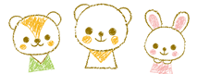
*The personal information provided on this form will be used solely for the purpose of this childcare service and will not be used for any other purpose.

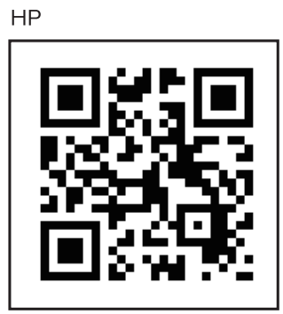

2F 2-6-7 MotoAsakusa Taito-Ku, Tokyo, 111-004
TEL 03-6231-6382 FAX 03-6860-1177
https:// www.combismile.co.jp /
Regular Member of All Japan Childcare Services Association

